**National Museum**



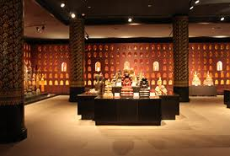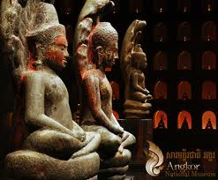Displaying a wide variety of military hardware and equipment in decrepit condition, taken from the battlefield. H eavy armor including T-54 tanks, anti-aircraft guns, artillery pieces, rocket launchers, APCs, small arms and piles of disarmed mines, bombs and small arms. Most of the larger pieces are labeled.