**Buffet Dinner with Apsara Show**

**$ 10/pax Only**

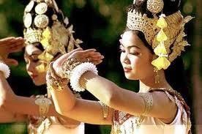

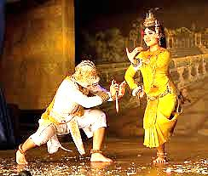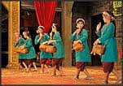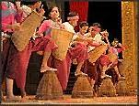No visit to Cambodia is complete without attending at least one traditional Khmer dance performance, often referred to as **'Apsara Dance**' after one of the most popular Classical dance pieces. **Traditional Khmer dance** is better described as 'dance-drama' in that the dances are not merely dance but are also meant to convey a story or message. There are four main modern genres of traditional Khmer dance: 1) Classical Dance, also known as Court or Palatine Dance (*lakhon preah reach troap* or *lakhon luong*); 2) Shadow theater (*sbeik thom* and *sbeik toot*); 3) *Lakhon Khol* (all-male masked dance-drama.); 4) Folk Dance (Ceremonial and Theatrical).

Price Include:

* Buffet Dinner ( Asian, Chines, Western)
* Apsara Dincing Show